CRYPTOCURRENCY & DIGITAL ASSETS
Blockchain Markets, Valuation, and Trading in a New Asset Class
From Blockchain Fundamentals to On-Chain Valuation, Derivatives, and Real-World Crises
A Level 2 module in the Quantitative Finance Curriculum
Covers: blockchain & consensus mechanisms · exchanges, wallets & custody · on-chain valuation metrics · perpetual futures & options · the basis trade · momentum & DeFi yield strategies · halving cycles · real-world case studies from Mt. Gox to Terra/Luna and FTX

Table of Contents
How to Use This Guide
What You Need to Know Before Starting
Understand Before Proceeding
Why It Matters
How This Connects to the Rest of the Curriculum
Glossary of Recurring Terms
Part 1 — Foundations: What Is Crypto?
1.1 Blockchain and Distributed Ledgers: The Core Technology
1.2 Bitcoin: Digital Scarcity and the First Cryptocurrency
1.3 Beyond Bitcoin: Ethereum, Smart Contracts, and Tokens
Part 2 — Crypto Market Structure and Mechanics
2.1 Mining, Staking, and Consensus Mechanisms
2.2 Exchanges, Wallets, and Custody
2.3 Market Microstructure: A 24/7, Fragmented Market
Part 3 — Valuation and Pricing Frameworks
3.1 Why Is Bitcoin Worth Anything? Valuation Approaches
3.2 On-Chain Metrics and Network Value
3.3 Crypto Derivatives: Futures, Perpetual Swaps, and Options
Part 4 — Trading and Investment Strategies in Crypto
4.1 The Basis Trade and Funding Rate Arbitrage
4.2 Momentum and Trend-Following in Crypto
4.3 DeFi Yield Strategies
4.4 Event-Driven Crypto: Halvings, ETFs, and Real-World Case Studies
Part 5 — Risk Management and Practical Considerations
5.1 Volatility and Crypto-Specific Risk Factors
5.2 Custody, Security, and Counterparty Risk
5.3 Pitfalls: Crashes, Contagion, and Regulatory Risk
Practical Exercise
Common Beginner Mistakes
Advanced Extensions
Professional Applications
Where to Go Next

How to Use This Guide
This document introduces cryptocurrency and digital assets, a distinctive and comparatively young asset class built on blockchain technology — a way of maintaining a shared, tamper-resistant record of transactions without relying on any single central authority. Crypto combines elements familiar from earlier parts of this curriculum (it has a spot market, a derivatives market, systematic strategies, and real, sometimes severe crises) with genuinely new elements that have no close analogue elsewhere in finance: a market that never closes, an asset whose supply schedule is fixed by open-source code rather than a central bank, and a set of on-chain data — every transaction, permanently and publicly recorded — that has no equivalent in traditional markets.
This module builds from the underlying blockchain technology up through how the market is actually structured and traded, how a crypto asset can be valued at all in the absence of cash flows, the strategies systematic traders run in the space, and the real-world booms, busts, and blow-ups that have repeatedly reshaped the industry. Each section follows the same pattern: the intuition first, then the formal mechanics, then a worked numerical example, then a figure, and finally a discussion of where the idea shows up in practice — including specific, named historical episodes. Read the module start to finish for the complete picture, or use the Table of Contents to jump to a specific topic — but do not skip Understand Before Proceeding below.

What You Need to Know Before Starting
- Basic statistics — mean, variance, and standard deviation; this module's treatment of volatility and on-chain metrics assumes comfort with these ideas.
- Basic derivatives concepts (helpful, not required) — familiarity with what a futures contract and an option are will make Part 3.3 easier, though this module explains crypto-specific instruments like the perpetual swap from first principles.
- Statistical Arbitrage and FX (recommended, not required) — Part 4 of this module applies the basis-trade and momentum logic from those modules directly to crypto markets, and readers familiar with those modules will recognize the underlying structure immediately.
- No prior blockchain or programming knowledge is assumed — Part 1 builds the core technology up from first principles.

Understand Before Proceeding
Prerequisite gate — Crypto assets do not generate cash flows the way a stock's dividends or a bond's coupons do, which means every valuation framework in this module — network value metrics, on-chain oscillators, or anything else — is an attempt to estimate a fair value indirectly, not a direct calculation of one the way a discounted cash flow model is for a company. Distinguishing between technology that is genuinely novel and useful (the blockchain itself, censorship-resistant settlement) and price action that is driven by speculation, leverage, and narrative is the central analytical skill this module is trying to build. The single most common and most costly error made by newcomers to this material is treating a compelling technological story as, by itself, a reason to expect a token's price to rise — a mistake this module returns to repeatedly, including through several detailed real-world case studies of what happens when that reasoning fails.

Why It Matters
Crypto matters for three reasons that go well beyond price speculation. First, it introduced a genuinely new financial primitive: a way to transfer and record ownership of value without a trusted intermediary, solving a problem — the so-called "double-spending problem" for digital assets — that had no working solution before Bitcoin's 2008 whitepaper and 2009 launch. Second, it created an unusually transparent laboratory for market behavior: because every transaction on a public blockchain is permanently visible, crypto markets generate an entirely new category of on-chain data that has no equivalent in traditional finance, and studying how that data does and does not predict prices is one of the more distinctive areas of modern quantitative research. Third, crypto's history is an unusually compressed lesson in financial risk-taking: in little more than a decade, the industry has produced dramatic bull markets, multiple severe crashes, exchange collapses, and outright fraud, offering a remarkably fast-moving case study in leverage, contagion, and counterparty risk that would otherwise take many decades to observe across traditional asset classes.
It also matters simply because of its scale: by the mid-2020s the total value of crypto assets has, at various points, exceeded the market capitalization of many entire national stock markets, institutional adoption has accelerated sharply (including the January 2024 approval of spot Bitcoin exchange-traded funds in the United States), and a meaningful and growing share of quantitative trading firms now run dedicated crypto desks alongside their traditional asset class coverage.

How This Connects to the Rest of the Curriculum
- Statistical Arbitrage — The basis trade covered in Part 4.1 is a direct application of the cash-and-carry and cointegration logic covered in that module's Parts 2 and 3, applied here to the spot-futures relationship in crypto markets.
- FX — Crypto's 24/7, globally fragmented market structure (Part 2.3) and its momentum-driven trading strategies (Part 4.2) echo structural themes from that module's treatment of the FX market's own trading sessions and trend-following strategies.
- Factor Models — Momentum, and increasingly value-like signals built from on-chain data, are studied in crypto using the same factor-construction logic covered in that module's Part 3.
- Risk Metrics & Portfolio Construction — The volatility, custody, and contagion risks covered in Part 5 of this module apply the portfolio risk-management framework from those modules to an asset class with distinctive tail-risk characteristics.

Glossary of Recurring Terms
Blockchain — A shared, append-only digital ledger in which transactions are grouped into blocks, each cryptographically linked to the previous block, maintained collectively by a decentralized network rather than any single party.
Distributed ledger — A database replicated and synchronized across many independent participants (nodes) rather than stored in one central location, of which a blockchain is the most common form used in crypto.
Consensus mechanism — The set of rules a blockchain network uses to agree on which transactions are valid and in what order they occurred, without relying on a central authority; Proof-of-Work and Proof-of-Stake are the two dominant approaches.
Proof-of-Work (PoW) — A consensus mechanism, used by Bitcoin, in which participants ("miners") compete to solve a computationally difficult puzzle, with the winner earning the right to add the next block and receive a block reward.
Proof-of-Stake (PoS) — A consensus mechanism, used by Ethereum since 2022, in which the right to validate the next block is allocated to participants ("validators") who have locked up ("staked") a quantity of the network's native token as collateral, rather than through computational competition.
Smart contract — Self-executing code deployed on a blockchain (most prominently Ethereum) that automatically carries out agreed-upon actions when specified conditions are met, without requiring a trusted intermediary.
Halving — A pre-programmed event, occurring roughly every four years on the Bitcoin network, that cuts the block reward paid to miners in half, directly reducing the rate at which new bitcoin is created.
Wallet — Software or hardware that stores the cryptographic private keys needed to authorize transactions on a blockchain, distinguished from an exchange account, which holds assets on the user's behalf rather than under the user's own direct control.
Custody — The safekeeping of the private keys or assets that control ownership of crypto holdings, either by the asset's own owner ("self-custody") or by a third party such as an exchange or dedicated custodian.
Perpetual futures (perps) — A crypto derivative contract that mimics a traditional futures contract but never expires, kept in line with the underlying spot price through a periodic funding-rate payment exchanged between long and short position holders.
Funding rate — The periodic payment exchanged between long and short holders of a perpetual futures contract, calibrated to keep the contract's price anchored to the underlying spot price.
Basis (crypto) — The difference between a crypto futures contract's price and the underlying spot price, which the basis trade covered in Part 4.1 seeks to capture.
On-chain metric — Any quantitative measure derived directly from public blockchain transaction data, such as active addresses, transaction volume, or the market-value-to-realized-value (MVRV) ratio, as distinct from off-chain data such as exchange order books.
DeFi (Decentralized Finance) — A category of financial applications — lending, trading, derivatives — built on smart-contract platforms and designed to operate without a traditional financial intermediary.
Stablecoin — A crypto token designed to maintain a stable value, typically pegged 1-to-1 to a fiat currency such as the US dollar, either through fully backed cash and short-term securities reserves (a collateralized stablecoin) or through an algorithmic mechanism (an algorithmic stablecoin).
Total value locked (TVL) — The aggregate dollar value of crypto assets deposited into a given DeFi protocol or across the DeFi ecosystem as a whole, commonly used as a rough measure of a protocol's scale and adoption.
Liquidation cascade — A rapid, self-reinforcing sequence of forced position closures in leveraged crypto markets, in which an initial price move triggers margin calls that force selling, which pushes the price further in the same direction and triggers further forced selling.

Part 1 — Foundations: What Is Crypto?
Part 1 builds the core technology underlying every cryptocurrency from first principles, introduces Bitcoin as the technology's first and still-dominant application, and surveys how the ecosystem has expanded well beyond Bitcoin into smart contracts and a much broader universe of tokens and applications.

1.1 Blockchain and Distributed Ledgers: The Core Technology
Every financial system needs a reliable way to answer a deceptively simple question: who owns what, right now? Traditional finance answers this question through trusted central intermediaries — a bank maintains the authoritative record of your account balance, a stock exchange's clearinghouse maintains the authoritative record of who owns which shares. A blockchain answers the same question differently: it maintains a single, shared, publicly verifiable record — a distributed ledger — replicated across many independent computers (nodes) around the world, with no single party in sole control of the record.
The ledger is organized into blocks, each containing a batch of recent transactions, a timestamp, and — critically — a cryptographic hash (a short, fixed-length digital fingerprint) of the previous block. Because each block's hash depends on the entire content of the block before it, altering any past transaction would change that block's hash, which would break the link to every subsequent block, which every node in the network would immediately detect. This is what makes a blockchain tamper-evident: rewriting history is not impossible in a mathematical sense, but doing so undetected against a large, widely distributed network is computationally infeasible in practice.
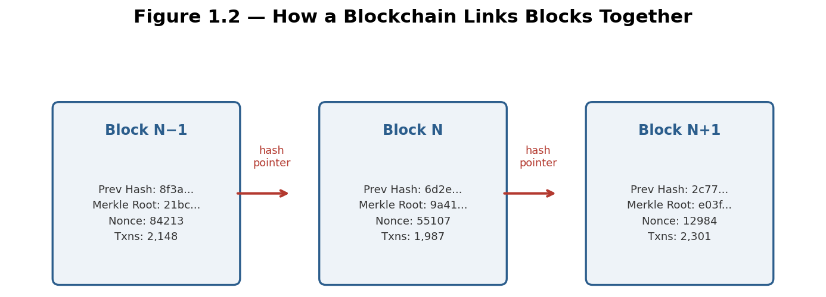
Figure 1.2 — Each block contains its own transactions and a hash pointer to the block before it, chaining every block together; altering any past block would change its hash and break every link that follows, which is exactly what the network's nodes check for.
Tip — "Blockchain" and "cryptocurrency" are often used interchangeably in casual conversation, but they are not the same thing. Blockchain is the underlying record-keeping technology; a cryptocurrency (like bitcoin, the asset) is one particular application of that technology, used to track ownership of a specific native asset. The same underlying technology can, and increasingly does, track ownership of many other things entirely — tokenized real-world assets, digital collectibles, and the smart contracts covered in Part 1.3.

1.2 Bitcoin: Digital Scarcity and the First Cryptocurrency
Bitcoin, launched in January 2009 following a whitepaper published in late 2008 by a pseudonymous author (or group) known as Satoshi Nakamoto, was the first successful application of blockchain technology and remains, by a wide margin, the largest cryptocurrency by market value. Bitcoin's core innovation was solving the double-spending problem — preventing someone from spending the same digital unit of value twice — without relying on any central authority to check for duplicate spending, using the combination of the blockchain structure from Part 1.1 and the Proof-of-Work consensus mechanism covered in Part 2.1.
Bitcoin's monetary policy is fixed directly into its open-source software: a maximum total supply of 21 million bitcoin will ever be created, released gradually to miners as a block reward that is automatically cut in half approximately every four years — an event known as the halving. This built-in, publicly verifiable scarcity, enforced by code and the collective agreement of the network rather than by any central bank's discretionary policy, is the foundation of the comparison frequently drawn between bitcoin and gold as a scarce, hard-to-debase store of value — a comparison at the center of the valuation debate covered in Part 3.1.
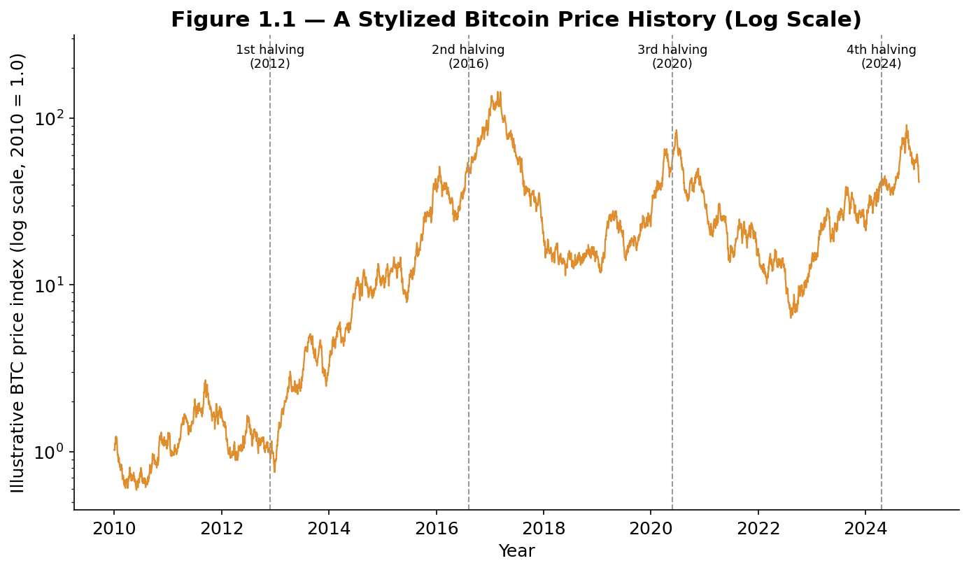
Figure 1.1 — Bitcoin's price history has been dominated by a repeating boom-bust cycle, loosely correlated with (though not mechanically caused by) the roughly four-year halving schedule; each cycle has produced both a larger peak and a larger trough than the one before it, in stylized, illustrative form.
Worked example — Bitcoin's block reward started at 50 BTC per block in 2009, fell to 25 BTC after the first halving in 2012, 12.5 BTC after the second halving in 2016, 6.25 BTC after the third halving in 2020, and 3.125 BTC after the fourth halving in 2024. Because new supply issuance falls by half at each halving while, historically, demand has not fallen by anywhere near as much, many market participants treat the halving as a structurally significant supply-side event — though, as Part 3.1 discusses, attributing any specific subsequent price move directly to the halving alone, rather than to the many other factors moving the market at the same time, requires real caution.

1.3 Beyond Bitcoin: Ethereum, Smart Contracts, and Tokens
Bitcoin's blockchain was deliberately designed to do one thing well: securely track ownership of a single native asset. Ethereum, launched in 2015, generalized the underlying idea dramatically by adding a built-in programming environment, allowing developers to deploy smart contracts — self-executing code that runs exactly as written, automatically, whenever specified conditions are met — directly on the blockchain. This turned the blockchain from a ledger that could only record "who owns how much of one asset" into a general-purpose platform capable of hosting entire financial applications without any traditional intermediary.
This capability gave rise to two major categories that now make up much of the broader crypto ecosystem beyond Bitcoin itself. Tokens are digital assets, distinct from a blockchain's own native currency, issued using standardized smart-contract templates on top of an existing blockchain (most commonly Ethereum) — ranging from tokens representing a share in a specific project or application, to stablecoins designed to hold a constant value, to non-fungible tokens (NFTs) representing unique digital or tokenized physical assets. Decentralized Finance (DeFi) applications use smart contracts to recreate traditional financial services — lending, borrowing, trading, derivatives — without a bank, broker, or exchange acting as intermediary, a category covered in detail in Part 4.3.
Common mistake — Assuming all cryptocurrencies work the same way Bitcoin does. Different blockchains make fundamentally different design trade-offs — in consensus mechanism, transaction speed and cost, programmability, and governance — and a valuation framework, risk factor, or trading strategy that is appropriate for Bitcoin will not automatically transfer correctly to a smart-contract platform token, a stablecoin, or a DeFi governance token, each of which has a meaningfully different economic structure.

Part 2 — Crypto Market Structure and Mechanics
Part 2 covers how crypto networks actually reach agreement on the state of the ledger, how the market for trading crypto assets is structured, and the distinctive mechanics — a market that never closes and is fragmented across many venues at once — that separate crypto trading from trading in most traditional asset classes.

2.1 Mining, Staking, and Consensus Mechanisms
Bitcoin's Proof-of-Work (PoW) consensus mechanism requires participants, called miners, to compete to solve a computationally intensive cryptographic puzzle; the first miner to find a valid solution earns the right to add the next block to the chain and collects the block reward plus transaction fees. This competition requires enormous, continuously growing amounts of real-world computing power (measured in hash rate), which is precisely what makes the network secure: rewriting past transactions would require re-doing the computational work for every subsequent block faster than the rest of the honest network can extend the real chain — a feat that becomes more difficult, and more expensive, as total network hash rate grows.
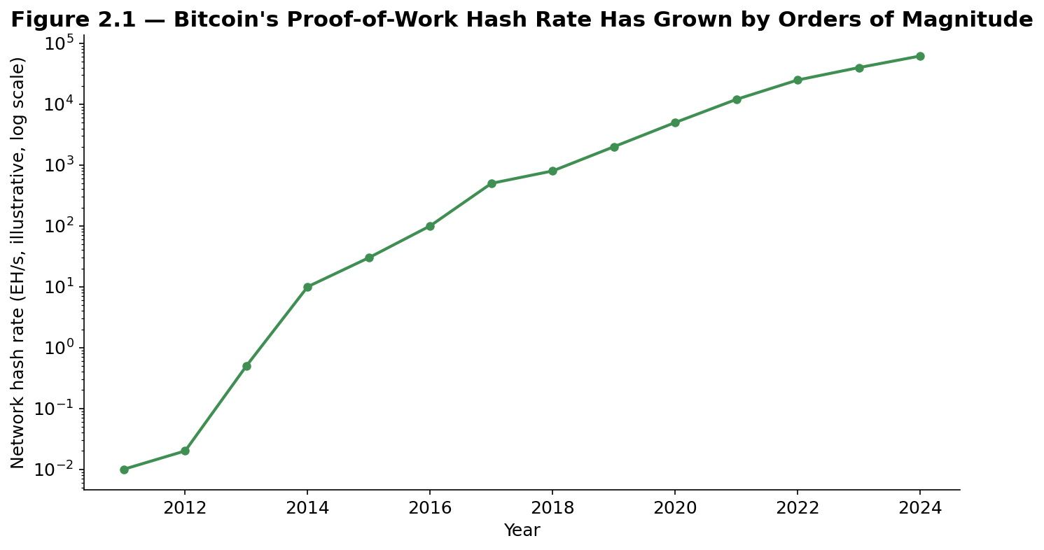
Figure 2.1 — Bitcoin's network hash rate has grown by roughly six orders of magnitude since 2011, reflecting a corresponding growth in the real-world computing power — and therefore the cost of attacking the network — securing the blockchain.
Proof-of-Stake (PoS), used by Ethereum since its September 2022 transition (known as "the Merge"), replaces computational competition with economic collateral: participants called validators lock up ("stake") a quantity of the network's native token, and the right to propose and validate the next block is allocated among validators roughly in proportion to their staked amount. A validator caught behaving dishonestly has a portion of their staked collateral destroyed ("slashed"), creating a direct economic incentive for honest behavior without requiring the large ongoing energy expenditure that Proof-of-Work requires — a difference that has made energy consumption a significant point of comparison, and public debate, between the two approaches.
Feature | Proof-of-Work (e.g., Bitcoin) | Proof-of-Stake (e.g., Ethereum)
Right to add next block | Won via computational competition | Allocated by staked collateral
Security cost | Ongoing real-world energy expenditure | Capital locked as slashable collateral
Dishonest-actor penalty | Wasted computation, no block reward | Staked collateral destroyed ("slashed")
Earning yield | Not directly — miners earn block rewards | Validators earn a staking yield directly

2.2 Exchanges, Wallets, and Custody
Most retail and institutional crypto trading happens on centralized exchanges — companies (such as Coinbase, Binance, and Kraken) that operate an order book, match buyers and sellers, and hold customers' assets on their behalf, functionally similar in structure to a traditional brokerage. Decentralized exchanges (DEXs), covered further in Part 4.3, instead use smart contracts to allow direct peer-to-peer trading without any company taking custody of user funds at all.
This distinction connects directly to one of the most important and distinctive concepts in the entire asset class: the difference between holding crypto on an exchange and holding it in self-custody. A wallet does not actually "store" crypto in the way a physical wallet stores cash — it stores the cryptographic private keys that authorize spending the assets recorded on the blockchain. Holding assets on an exchange means trusting that exchange to safeguard the private keys and to honor withdrawal requests; holding assets in a self-custody wallet means the user alone controls the private keys, with no third party able to freeze, seize, or lose the funds on the user's behalf — but also no third party able to help recover them if the user's own keys are lost or stolen. This trade-off, memorably summarized in the crypto community as "not your keys, not your coins," is central to the custody risk discussion in Part 5.2 and to several of this module's real-world case studies.

2.3 Market Microstructure: A 24/7, Fragmented Market
Unlike traditional equity or bond markets, which close overnight and on weekends, crypto markets trade continuously, 24 hours a day, seven days a week, with no scheduled close at all — a structural feature shared conceptually with the FX market's continuous trading, but taken even further, since FX still effectively pauses over the weekend while crypto does not. This has practical consequences: significant news can move prices sharply at any hour with no circuit breaker or scheduled reopening to allow the market to digest it, and liquidity can vary meaningfully depending on which region's trading day is active at any given moment.
Crypto trading is also considerably more fragmented than trading in most traditional asset classes: rather than a small number of primary exchanges, the same asset trades simultaneously across dozens of centralized exchanges (each maintaining its own separate order book and, at times, a meaningfully different price) and an even larger number of decentralized exchanges. This fragmentation is precisely what creates the arbitrage opportunities that a meaningful share of systematic crypto trading activity is built around — buying an asset on the exchange where it is temporarily cheaper and selling where it is temporarily more expensive, conceptually similar to the cross-exchange arbitrage covered in the Statistical Arbitrage module's Part 4.4, but occurring far more frequently in crypto given the market's greater fragmentation and historically wider cross-venue price discrepancies.
Tip — Because crypto never closes, standard portfolio risk practices built around a daily close-of-business snapshot (an end-of-day value-at-risk calculation, for example) can understate real intraday and overnight risk in a way that is less of a concern in markets with a genuine daily close. Professional crypto risk management typically relies on continuous, real-time position and risk monitoring rather than a single daily checkpoint.

Part 3 — Valuation and Pricing Frameworks
Part 3 confronts the question every newcomer to crypto eventually asks: what determines what these assets are actually worth? It surveys the main competing valuation approaches, the on-chain metrics unique to this asset class, and the derivative instruments — including one, the perpetual future, that has no direct equivalent in traditional markets — used to trade and hedge crypto exposure.

3.1 Why Is Bitcoin Worth Anything? Valuation Approaches
Unlike a stock, bitcoin generates no dividends, earnings, or cash flows, which means the discounted cash flow framework used to value companies simply does not apply. Several alternative valuation approaches have been proposed, each with real explanatory value and real limitations:
- The monetary/store-of-value view — Treats bitcoin as analogous to a scarce commodity like gold, with value derived from its fixed, verifiable, censorship-resistant supply schedule (Part 1.2) rather than from any cash flow — the same logic behind gold's valuation, which similarly generates no cash flow of its own.
- Metcalfe's Law and network-value approaches — Borrowed from telecommunications economics, the idea that a network's value scales roughly with the square of its number of active users, giving a rough framework for relating a token's price to growth in its actual on-chain usage (Part 3.2).
- The cost-of-production view — Draws an analogy to commodity mining, arguing that a Proof-of-Work asset's price should not persistently trade too far below the marginal cost of mining it (electricity, hardware, and other operating costs), since miners would otherwise have no incentive to keep securing the network.
- The pure speculation / narrative view — Argues that, absent cash flows or a clear fundamental anchor, crypto prices are driven substantially by shifting narratives, momentum, and speculative positioning rather than by any calculable fair value at all — a view with real empirical support given the magnitude and frequency of crypto's boom-bust cycles.
Tip — None of these frameworks commands anything close to universal acceptance, and each performs differently well at different points in the market cycle — the monetary/store-of-value narrative tends to dominate during sustained bull markets, while the pure speculation view tends to dominate the conversation after a sharp crash. A useful discipline is to treat each framework as one input into a broader picture rather than as a definitive answer, and to be explicit about which framework any given valuation claim — your own or someone else's — is actually relying on.

3.2 On-Chain Metrics and Network Value
Because every transaction on a public blockchain is permanently recorded and visible, crypto markets support an entire category of valuation and sentiment indicators — on-chain metrics — with no real equivalent in traditional finance, where a comparable degree of transaction-level transparency simply does not exist. One of the most widely used is the MVRV ratio (Market Value to Realized Value): market value is simply price times circulating supply, while realized value estimates the aggregate cost basis of all coins by valuing each coin at the price it last moved on-chain, rather than at the current price.
MVRV = Market Value / Realized Value
An MVRV ratio well above 1 suggests that, in aggregate, current holders are sitting on large unrealized gains relative to their original cost basis — historically associated with periods of market euphoria and elevated risk of profit-taking — while an MVRV ratio below 1 suggests the average holder is underwater, historically associated with periods of capitulation and, at times, longer-term value. The MVRV Z-score, a standardized version of the same idea, is one of the more widely followed on-chain oscillators in the crypto research community.
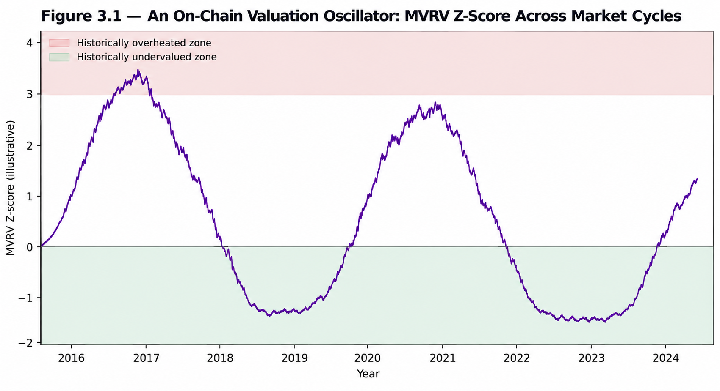
Figure 3.1 — An on-chain valuation oscillator like the MVRV Z-score has, historically, tended to reach extreme readings close to major cycle tops and bottoms — though, as with any single indicator, using it as a mechanical timing signal on its own carries real risk, discussed further in Part 5.3.
Other widely used on-chain metrics include active addresses (a rough proxy for network usage, feeding directly into Metcalfe's Law-style approaches), the NVT ratio (Network Value to Transactions, an on-chain analogue to a price-to-sales ratio, comparing market value to the dollar value of on-chain transaction activity), and exchange flow metrics (tracking the net movement of coins onto or off of exchanges, often interpreted as a proxy for near-term selling or holding intent). None of these metrics has been shown to reliably and mechanically predict future price moves, and all are best treated as one input among several rather than a standalone trading signal.

3.3 Crypto Derivatives: Futures, Perpetual Swaps, and Options
Crypto derivatives markets have grown to trade a substantially larger notional volume than crypto spot markets themselves, and they include one instrument — the perpetual future, or "perp" — that was invented specifically for crypto markets and has no direct historical equivalent in traditional finance. A perpetual future behaves like a standard futures contract (its price tracks an underlying asset, and it can be traded with leverage) but has no expiration date. Because there is no expiration to force convergence between the futures price and the spot price the way a traditional futures contract's expiry does, perpetual futures instead use a funding rate: a periodic payment (typically every eight hours) exchanged directly between long and short position holders, calibrated so that when the perpetual trades above spot, longs pay shorts (discouraging further long positioning and encouraging shorts), and vice versa when it trades below spot.
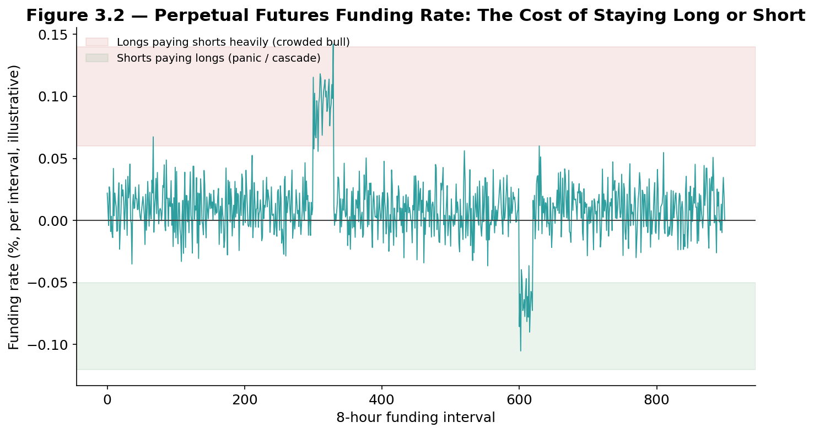
Figure 3.2 — The perpetual futures funding rate oscillates around zero under normal conditions but can spike sharply during a crowded bull market (longs paying shorts heavily) or during a panic-driven cascade of long liquidations (shorts briefly paying longs).
A persistently and significantly positive funding rate is a direct, continuously updated market signal of how aggressively leveraged the market's long positioning has become — a useful, real-time gauge of speculative excess that, again, has no close equivalent in traditional derivatives markets, where funding costs are not typically observable at this frequency or interpreted as a sentiment signal in the same way. Standard, dated futures contracts (with a fixed expiration, trading on venues including the CME since December 2017) and options (using a similar Black-Scholes-family framework to the FX options covered in the FX module's Part 3.3, adapted for crypto's typically much higher volatility) round out the derivatives landscape, and are used for hedging, directional speculation, and the basis trading strategy covered next in Part 4.1.
Worked example — A perpetual future trades at $61,200 while the underlying spot price is $61,000, an annualized funding rate of roughly 10.6% is charged to long position holders and paid to short position holders every eight hours until the two prices converge. A trader who is simultaneously long spot bitcoin and short an equal notional amount of the perpetual future is fully hedged against bitcoin's price moving in either direction, while collecting the funding payments from the crowded long side of the perpetual market — precisely the mechanics behind the basis trade covered in Part 4.1.

Part 4 — Trading and Investment Strategies in Crypto
Part 4 surveys the major systematic strategies run in crypto markets today, several of which apply logic already introduced elsewhere in this curriculum directly to digital assets, and closes with a detailed look at the specific real-world events — halvings, ETF approvals, and several major crises — that have shaped the asset class's history.

4.1 The Basis Trade and Funding Rate Arbitrage
Building directly on Part 3.3, the basis trade (also called cash-and-carry) is one of the most widely used market-neutral strategies in crypto: simultaneously buy spot bitcoin and sell (short) an equal notional amount of a bitcoin future or perpetual swap, capturing the price difference (the "basis") between the two while remaining fully hedged against bitcoin's own price direction. In a dated futures contract, this basis is captured as the futures price converges to spot by expiration; in a perpetual swap, it is captured continuously through the funding rate payments described in Part 3.3.
Basis return (annualized) ≈ Funding rate × (365 / 8-hour intervals per year) (for a perpetual-swap basis trade)
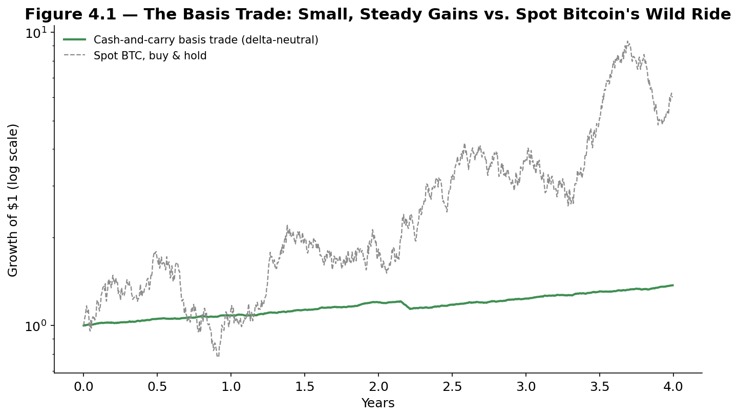
Figure 4.1 — A delta-neutral basis trade produces a comparatively small, steady return stream, in sharp visual contrast to spot bitcoin's much larger and far more volatile price swings — the same market-neutral signature seen in the Statistical Arbitrage module's pairs-trading strategies.
The basis trade's return is directly tied to how aggressively the market's leveraged long positioning has become: during periods of intense bullish speculation, funding rates and futures premia can rise sharply, offering basis traders an unusually attractive, largely market-neutral yield — one of the more consistently cited institutional entry points into crypto markets, since it allows a fund to earn a return tied to crypto market conditions without taking on bitcoin's own outright price risk.

4.2 Momentum and Trend-Following in Crypto
Momentum strategies, directly analogous to the trend-following approaches covered in the FX module's Part 4.2, have been extensively documented in crypto markets: assets that have performed well over the trailing weeks to months have historically tended to continue outperforming over the following period, and vice versa for recent underperformers. Crypto's pronounced boom-bust cyclicality (visible directly in Figure 1.1) and its historically strong retail-driven sentiment feedback loops are frequently cited as structural reasons momentum has been an unusually persistent and pronounced signal in this asset class relative to more mature, institutionally dominated markets.
A related, crypto-specific variant is cross-sectional momentum across tokens: ranking a broad universe of crypto assets by trailing relative performance and going long the recent outperformers while shorting (or underweighting) the recent underperformers, directly analogous to the cross-sectional mean-reversion and momentum strategies covered in the Statistical Arbitrage and Factor Models modules, applied here to a universe of tokens rather than equities.

4.3 DeFi Yield Strategies
Decentralized Finance (DeFi), introduced in Part 1.3, gives rise to a distinctive family of yield-generating strategies with no direct equivalent in traditional finance. Staking — locking up a Proof-of-Stake network's native token to help validate transactions, as covered in Part 2.1 — earns a yield paid directly by the protocol, conceptually similar to earning interest, but with the added risk that staked assets can be partially destroyed ("slashed") for validator misbehavior and are typically subject to a lock-up or unstaking delay period.
Liquidity provision on a decentralized exchange involves depositing a pair of tokens into a smart-contract-managed pool that other users trade against, earning a share of trading fees in return — but exposing the liquidity provider to impermanent loss, a distinctive risk in which the value of the deposited assets, measured against simply holding them outright, can decline if the two tokens' relative price moves significantly while the funds are deposited in the pool. Yield farming generalizes this further, actively moving capital between different DeFi protocols and incentive programs to chase the highest available combined yield, often layering multiple strategies (staking a liquidity-pool token itself, for example) to amplify returns — and, correspondingly, amplifying the underlying smart-contract and protocol risk being taken on.
Common mistake — Treating a DeFi protocol's advertised annual percentage yield (APY) as a risk-free interest rate comparable to a bank savings account. A high advertised DeFi yield typically compensates for one or more real, sometimes severe risks: smart-contract bugs or exploits, the issuing protocol's own token depreciating (when yield is paid in the protocol's native token rather than a stablecoin), impermanent loss, or the yield itself being temporarily subsidized by the protocol to attract deposits, unsustainable once that subsidy ends.

4.4 Event-Driven Crypto: Halvings, ETFs, and Real-World Case Studies
Beyond systematic strategies, crypto's history has been shaped by a series of specific, well-documented events worth understanding individually:
- The 2017 ICO boom and bust — A wave of "initial coin offerings" — new token sales, many with minimal underlying technology or business substance — raised billions of dollars from retail investors through 2017, driving bitcoin and the broader market to then-record highs near the end of the year, before a sharp, prolonged decline through 2018 (often called "crypto winter") as the large majority of ICO-funded projects failed to deliver on their stated goals.
- Institutional adoption, 2020–21 — Public companies including MicroStrategy and, briefly, Tesla added bitcoin to their corporate treasuries, the CME's regulated bitcoin futures market matured, and a wave of institutional interest helped drive a sustained bull market through 2020 and into 2021, alongside a boom in DeFi activity ("DeFi Summer") and non-fungible tokens.
- The Terra/Luna collapse (May 2022) — TerraUSD (UST), a large algorithmic stablecoin designed to maintain its dollar peg through an automated arbitrage mechanism with its sister token LUNA rather than through holding real dollar reserves, lost its peg amid heavy selling; the resulting collapse destroyed tens of billions of dollars in value within days and stands as the canonical case study in algorithmic stablecoin design failure.
- The FTX collapse (November 2022) — FTX, at the time one of the world's largest crypto exchanges, filed for bankruptcy within days after reporting revealed that customer deposits had reportedly been used to fund trading losses and other obligations at Alameda Research, an affiliated trading firm — becoming the canonical case study in exchange counterparty and custody risk, discussed further in Part 5.2, and its founder was later convicted of fraud.
- The Bitcoin ETF approval (January 2024) — The US Securities and Exchange Commission approved the first spot bitcoin exchange-traded funds, allowing traditional brokerage-account investors to gain bitcoin price exposure without directly holding or self-custodying the underlying asset, widely regarded as a major milestone in crypto's integration with mainstream, regulated financial markets.
Together, these episodes illustrate a recurring pattern worth carrying forward into Part 5: crypto's largest moves have come not only from the gradual operation of the strategies covered earlier in this part, but from discrete, sometimes sudden events — a design flaw revealed under stress, a counterparty failure, or a shift in the regulatory and institutional landscape.

Part 5 — Risk Management and Practical Considerations
The final part turns from strategy and valuation to the practical discipline of managing risk in crypto markets: the asset class's distinctive volatility profile, the custody and counterparty risks that have produced some of its largest losses, and the recurring pitfalls — cascading liquidations, contagion, and regulatory uncertainty — every serious crypto market participant needs to understand.

5.1 Volatility and Crypto-Specific Risk Factors
Bitcoin's realized volatility has, across nearly its entire trading history, run several multiples higher than that of major equity indices — a structural feature of the asset class driven by its comparatively small market size relative to the capital that can flow in and out of it, its 24/7 trading with no circuit breakers, and sentiment- and leverage-driven feedback loops that can amplify both rallies and selloffs.
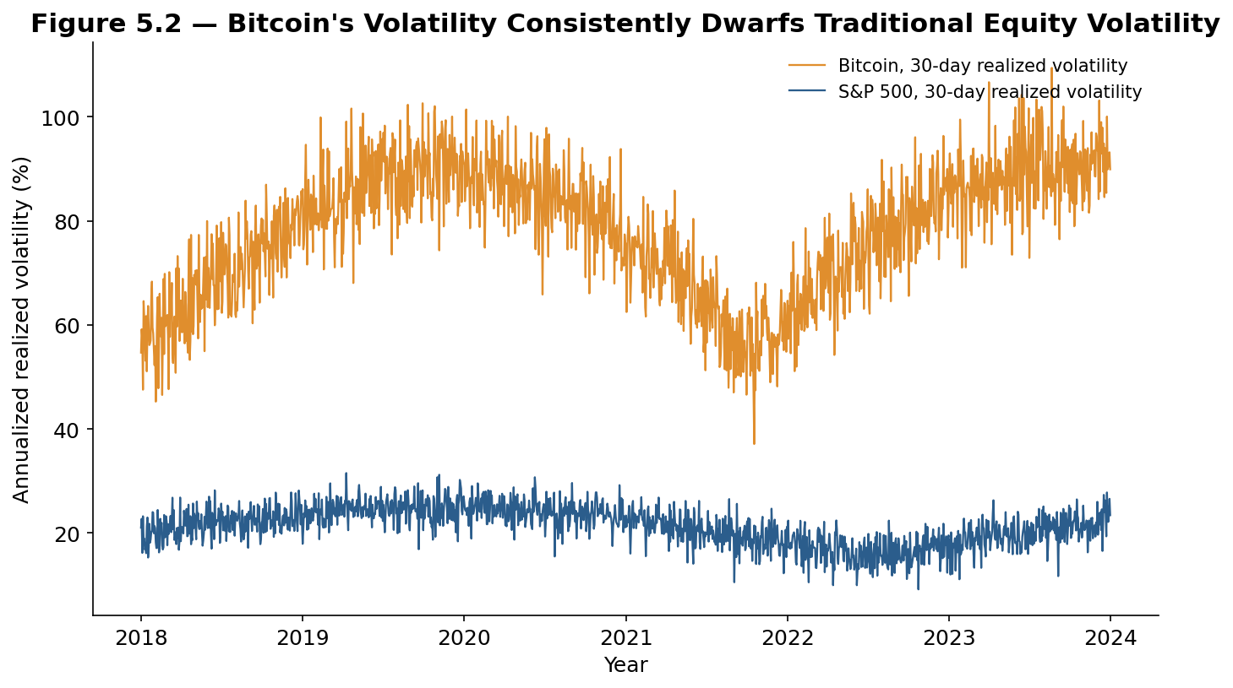
Figure 5.2 — Bitcoin's 30-day realized volatility has consistently run several multiples above the S&P 500's, and while crypto volatility has gradually trended somewhat lower as the asset class has matured, it remains structurally far higher than traditional equities.
Beyond raw volatility, crypto carries several risk factors with no close equivalent in traditional asset classes: smart-contract risk (a bug or exploit in a DeFi protocol's code can result in a total, instantaneous loss of deposited funds, as covered in Part 4.3), leverage-driven liquidation cascades (covered next), and regulatory risk (the treatment of crypto assets under securities, banking, and tax law continues to evolve significantly across jurisdictions, and a regulatory action in a major market can move prices sharply with little advance warning).
Tip — A liquidation cascade occurs when an initial price move forces highly leveraged traders' positions to be automatically closed (liquidated) by an exchange or lending protocol, and that forced selling (for a liquidated long) or buying (for a liquidated short) itself pushes the price further in the same direction, triggering the next tier of leveraged positions to be liquidated in turn. This dynamic, visible directly in the funding-rate spikes shown in Figure 3.2, is a major contributor to crypto's characteristically sharp, fast-moving crashes and rallies, and is a direct consequence of how widely available and heavily used high leverage is across crypto derivatives venues relative to most traditional markets.

5.2 Custody, Security, and Counterparty Risk
Building on the self-custody versus exchange-custody distinction introduced in Part 2.2, crypto's history includes a long list of exchange failures and security breaches, several of which rank among the largest single financial losses in the asset class's history. Mt. Gox, once the world's largest bitcoin exchange, collapsed in 2014 after losing roughly 850,000 bitcoin (worth many billions of dollars at subsequent prices) to a combination of hacking and alleged mismanagement, in what remains one of the earliest and most consequential cautionary tales about exchange counterparty risk. The FTX collapse described in Part 4.4 delivered essentially the same lesson to a new generation of market participants nearly a decade later, this time driven primarily by alleged fraud and misuse of customer funds rather than external hacking.
The practical risk-management lesson from both episodes, and from the many smaller exchange failures between them, is direct: holding crypto on an exchange means bearing that exchange's own counterparty risk — its solvency, its internal controls, and its integrity — in addition to the market risk of the underlying asset itself, and that counterparty risk is entirely separate from, and in several historical cases has proven considerably larger than, the price risk of the crypto asset itself.
Common mistake — Assuming that because an exchange is large, well-known, or heavily used, it is therefore safe to hold significant assets on it indefinitely. FTX was, by trading volume and public profile, one of the largest and most prominent exchanges in the world immediately before its collapse. Institutional and sophisticated market participants increasingly treat exchange and counterparty concentration as a risk to be actively managed and diversified — for example, by limiting the share of total assets held on any single exchange, and by using dedicated third-party or self-custody solutions for longer-term holdings — rather than as a risk that can be assumed away based on an exchange's size or reputation alone.

5.3 Pitfalls: Crashes, Contagion, and Regulatory Risk
The Terra/Luna and FTX episodes from Part 4.4 were not isolated events — they were connected links in a single contagion cascade that defined crypto markets through 2022, and understanding that connection is essential context for evaluating risk in this asset class.
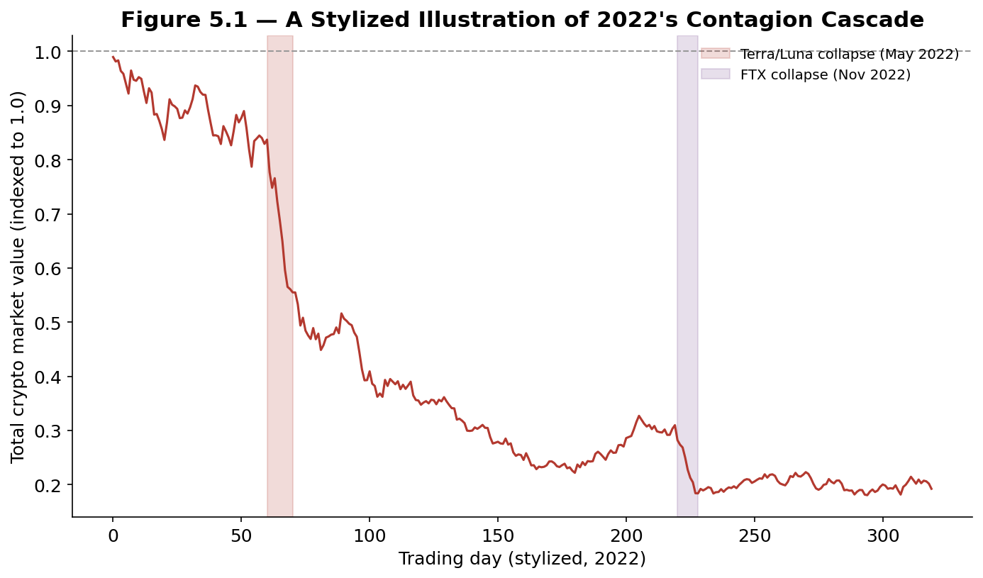
Figure 5.1 — A stylized illustration of 2022's contagion cascade: the Terra/Luna collapse in May triggered a wave of losses at crypto lenders and hedge funds with exposure to it, weakening the broader industry's balance sheets months before the FTX collapse in November delivered a second, even sharper shock.
The Terra/Luna collapse in May 2022 did not stay contained to that one project: several major crypto lending platforms and hedge funds (including Celsius Network, Voyager Digital, and the hedge fund Three Arrows Capital) had significant direct or indirect exposure to Terra/Luna or to counterparties that did, and each subsequently failed or filed for bankruptcy over the following months, in a cascading sequence of counterparty failures often compared to the interconnected bank failures of a traditional financial crisis. The FTX collapse in November 2022 then delivered a second, largely independent shock to an industry whose balance sheets and confidence had already been significantly weakened by the first.
- Contagion — As 2022 demonstrated clearly, crypto institutions are frequently interconnected through lending, trading, and counterparty relationships in ways that are not always visible from the outside, meaning a single large failure can propagate losses well beyond the entity directly involved.
- Regulatory risk — Crypto's legal and regulatory treatment continues to evolve significantly and unevenly across jurisdictions; a regulatory action — an enforcement action against a major exchange, a new restriction on stablecoins, or an outright ban in a major market — can move prices sharply and with relatively little advance warning, a risk with no close equivalent in more mature, settled regulatory environments.
- Reflexivity between price and fundamentals — Because much of crypto's on-chain activity (DeFi collateral values, staking yields, project treasuries) is itself denominated in volatile crypto assets, a sharp price decline can directly damage the underlying fundamentals it was supposedly unrelated to — collateral gets liquidated, treasuries shrink, and projects lose the resources to continue development — creating a feedback loop between price and fundamentals that is considerably tighter than in most traditional asset classes.
Tip — When evaluating risk in a crypto position, it is rarely sufficient to ask only "what happens if the price of this asset falls?" The 2022 contagion cascade shows why it is equally important to ask "which counterparties, platforms, and protocols does my exposure to this asset run through, and what happens to me if one of them fails, even if the underlying asset's price itself is unaffected?" — a question that maps directly onto the counterparty and custody risk framework introduced in Part 5.2.

Practical Exercise
Choose one major cryptocurrency (for example, bitcoin or ether) and gather at least three years of daily spot price data, along with the corresponding perpetual futures funding rate history if available. Work through the checklist below before drawing any conclusions about the strategies and risks covered in this module.

Crypto strategy and risk validation checklist
- Compute realized volatility over rolling windows — and compare it to a traditional equity index over the same period, confirming the scale of the difference shown in Figure 5.2.
- Identify the largest historical drawdowns — and check whether each coincides with a specific, identifiable event (a halving cycle top, a major exchange failure, a broad risk-off period) rather than assuming drawdowns are randomly distributed through time.
- Estimate a simple basis trade's historical return — using available funding rate data, and compare its volatility and drawdown profile to simply holding the spot asset outright.
- Map your own (or a hypothetical) crypto exposure's counterparty chain — listing every exchange, lending platform, or protocol involved, and identify the single largest counterparty concentration in that chain.
- Stress test against a known event — apply the actual percentage decline from the Terra/Luna or FTX episodes to a current position size, and confirm the resulting hypothetical loss would be survivable under your own risk limits.
# Skeleton for the practical exercise

def realized_volatility(prices, window=30, periods_per_year=365):
log_ret = np.log(prices / prices.shift(1))
rolling_std = log_ret.rolling(window).std()
return rolling_std * np.sqrt(periods_per_year)

def basis_trade_return(funding_rate, intervals_per_year=1095):
# funding_rate: per-interval funding rate paid to the short
# (e.g. an 8-hour funding interval, 3 per day = 1095 per year)
annualized_return = funding_rate.mean() * intervals_per_year
return annualized_return

def max_drawdown(prices):
running_max = prices.cummax()
drawdown = (prices - running_max) / running_max
return drawdown.min()

# Evaluate: realized volatility vs. a traditional equity benchmark,
# the basis trade's estimated Sharpe ratio, and a written note on
# what your largest counterparty concentration is and why.

Common Beginner Mistakes
- Confusing the technology story with the price thesis — treating blockchain's genuine technical usefulness as, by itself, a reason to expect any specific token's price to rise, without a clear framework for how that usefulness translates into value capture for holders of the token.
- Leaving significant holdings on a single exchange indefinitely — without considering counterparty concentration risk, as both the Mt. Gox and FTX collapses illustrate directly.
- Chasing high DeFi yields without understanding what risk they compensate for — smart-contract risk, token depreciation, impermanent loss, or an unsustainable, temporarily subsidized rate.
- Using excessive leverage in a 24/7, highly volatile market — without accounting for the risk of a liquidation cascade occurring at any hour, with no scheduled market close to provide a pause.
- Treating on-chain metrics as mechanical trading signals — rather than as one input among several, given that no single on-chain indicator has been shown to reliably and consistently predict future price moves on its own.

Advanced Extensions
The following are Level 3–5 topics, introduced here only by name so you know what to look for when you reach them:
- Maximal extractable value (MEV) — the study of how blockchain transaction ordering can be exploited for profit (for example, by inserting trades immediately before and after a known pending transaction), and the market microstructure implications for DeFi trading.
- Cross-chain and bridge risk — the mechanisms used to move assets between different blockchains, and the distinctive security risks (several major hacks have specifically targeted these "bridges") that arise from doing so.
- Quantitative on-chain factor models — combining multiple on-chain metrics (Part 3.2) with traditional price-based factors into systematic, backtested multi-factor models, extending the single-indicator oscillator approach described in this module.

Professional Applications
- Crypto-native quantitative trading firms — Firms such as Jump Crypto, Wintermute, and GSR run market-making, basis-trading, and arbitrage strategies across the fragmented, 24/7 market structure described in Part 2.3.
- Traditional asset managers and ETF issuers — Increasingly offer regulated crypto exposure following the 2024 spot Bitcoin ETF approvals described in Part 4.4, extending institutional access to the asset class.
- Crypto lending and custody platforms — Provide the institutional-grade custody solutions that directly address the counterparty risk described in Part 5.2, an increasingly important category following the exchange failures covered throughout this module.

Where to Go Next
This module covered cryptocurrency from the underlying blockchain technology through market structure, valuation frameworks and on-chain metrics, the derivatives and strategies used to trade the asset class, and the real-world events and risks that have shaped its history. The Statistical Arbitrage module's Part 2 covers the cash-and-carry logic this module's Part 4.1 applies directly to the crypto basis trade; the FX module's Part 1.3 and Part 4.2 cover the 24-hour market structure and trend-following logic this module extends to crypto; and the Risk Metrics module builds on this module's Part 5 to cover portfolio-level tail-risk measurement, including approaches to sizing positions in a structurally higher-volatility asset class.

